Week 2 Module 2.2 Assignment
Loop Structure Table

Juan Macias Vasquez
Bellevue University
CSD440-H323 Server-Side Scripting (2265-DD)
Jack Lusby
April 2nd, 2026

Week 2 Module 2.2 Assignment
Loop Structure Table
GitHub Repository
https://github.com/Juan551School/csd-440

This program Generates a random number between 1 and 100 in table
It is under 100 to make sure that the number isn’t too big and makes the table end up in a weird length.

Code
JuanTable2.php
<!--
Name: Juan Macias Vasquez
File: JuanTable2.php
Module 2 Assignment
Bellevue University
CSD440-H323 Server-Side Scripting (2265-DD)
Jack Lusby
April 2nd, 2026
-->

<!DOCTYPE html>
<html lang="en">
<head>
<meta charset="UTF-8">
<title>PHP Random Number Table</title>
<style>
table {
border-collapse: collapse;
margin: 20px auto;
}
td {
border: 1px solid black;
padding: 10px;
text-align: center;
width: 50px;
}
</style>
</head>
<body>

<h2 style="text-align:center;">Random Number Table</h2>

<table>
<?php
/*
Description: This program generates a table using nested PHP loops.
Each cell displays a random number between 1 and 100.
*/
// The Outer loop for rows
for ($row = 1; $row <= 5; $row++) {
?>
<tr>
<?php
// The Inner loop for columns
for ($col = 1; $col <= 5; $col++) {
$randomNumber = rand(1, 100);
?>
<td><?php echo $randomNumber; ?></td>
<?php
}
?>
</tr>
<?php
}
?>
</table>

</body>
</html>

Pictures of Steps Complete
Test 1
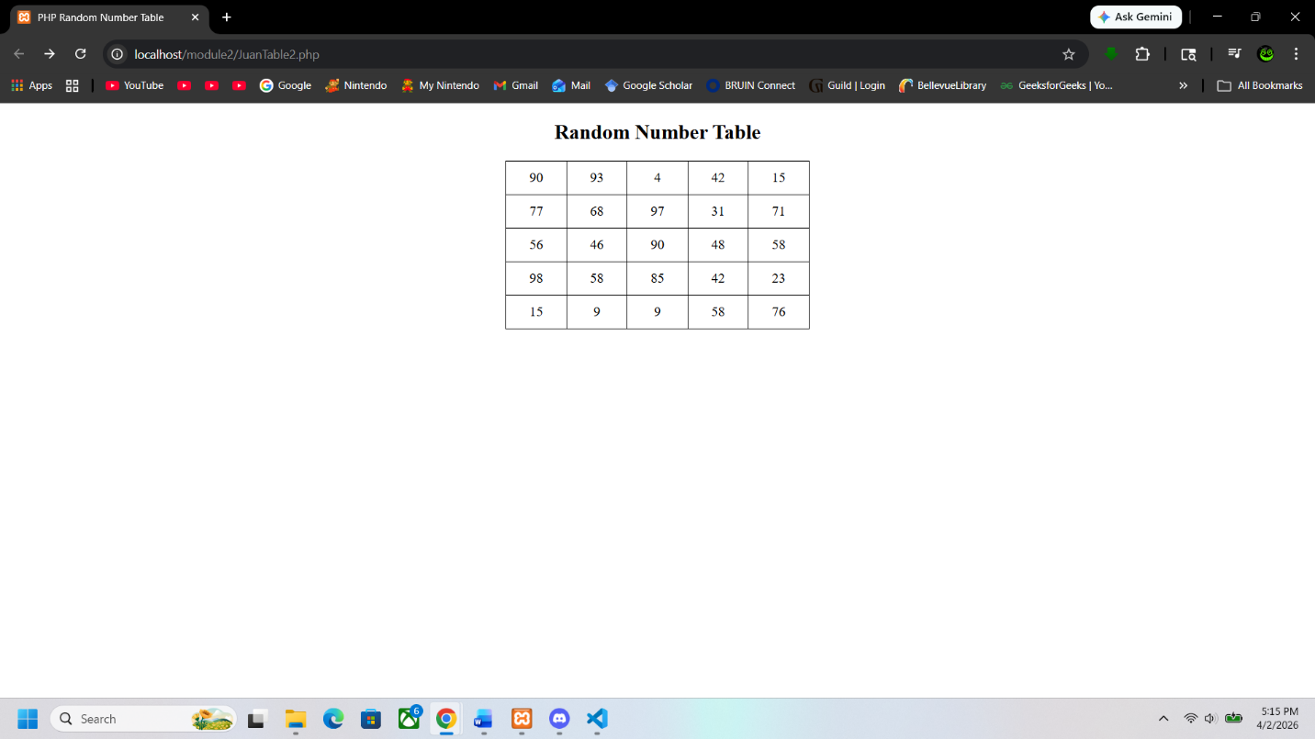
Test 2
